INDIGENOUS DEVELOPMENT ORGANISATION

**Regd. Society No: 434 of 2019**

**ANNUAL REPORT 2021-22**



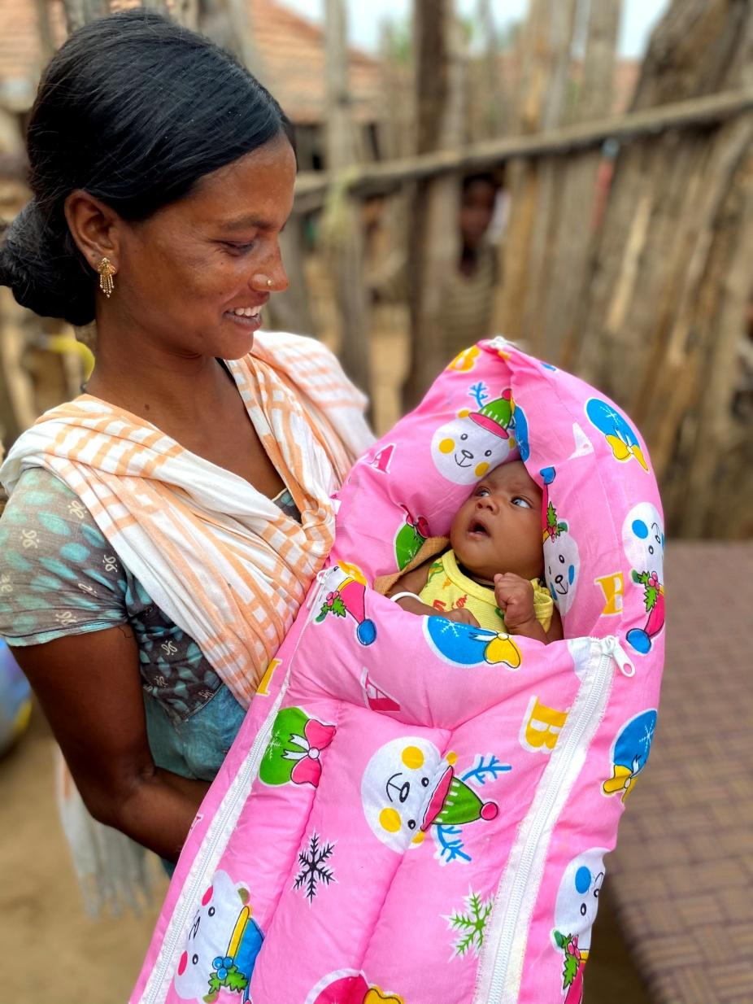



| **LIST OF THE BOARD MEMBERS 2019-2020** | | |
| --- | --- | --- |
| **DESIGNATION** | **NAME** | **BACKGROUND** |
| President | Dr. N. Ravindra Rao | Doctor |
| Vice President | Mogili Vijender | Social Entrepreneur |
| Secretary & Founder | Dr. R. Narendar | Doctor |
| Treasurer | Mahesh Mandava | IT Professional |
| Joint Secretary | K. Mallikarjuna Rao | Business |
| Executive Member | B. V. Radhakrishna Murthy | IT Professional |
| Executive Member | Dr. Suresh Reddy | Doctor |

* **ABOUT NGO:** We are working with tribal community in the interior forest habitations (IFHs) & rural villages of the Bhadradri kothagudem district, Telangana. Tribal communities comprise of 37% of overall population in the district. Bhadradri Kothagudem shares it boundaries with Khammam, AP & Chhattisgarh. Majority of tribal communities does not have access to universal healthcare services & due to poor economic status they cannot afford healthcare, nutrition and access to education.

Inspired by philosophy of Sri. APJ Abdul Kalam and humanitarian works of Dr Hanumappa Sudarshan, Dr Prakash Amte and Dr Abhay Bang, Dr Narendar (Founder) in 2016-17 started to visit various regions to understand the needs of communities & finally came across the Bhadradri Kothagudem district in Telangana. After looking at the challenges faced by tribal communities, he decided to work for them & started staying with them since then.

* **OUR MISSION:** We work with marginalized communities – tribal, rural, women and children – bringing health awareness, providing access to healthcare services, nutrition and education, bringing in community empowering models to address those challenges. The model focuses to reduce deaths, diseases, malnutrition & illiteracy.
* Indigenous Development Organisation strives to achieve its objectives through following programs:

1. Health Clinic at Gattumalla village
2. Monthly Training sessions for Community Health Workers
3. Home-based maternal & newborn care
4. Seemantham monthly event for pregnant women
5. Nutrition program & Nutritional assessments
6. Bridge schools

As interior regions of the district have poor access to healthcare & the tribal community has poor health seeking behaviour, owing to this the maternal and child health indicators are poor in the district. Infant mortality rate is very high. Malnutrition, Anaemia & Malaria prevalence is also very high.

**HEALTH CLINIC:**

* The health clinic was setup at Gattumalla village, Lakshmidevipalli mandal, Bhadradri Kothagudem district with an aim to establish a channel where the patients requiring further diagnosis/ interventions can be brought-in by our trained CHWs and also for over 15000 population around this clinic to reach us conveniently.
* Primary healthcare services (Allopathic & Homeopathic), Antenatal screening & routine lab investigations are done at clinic.

| Health clinic- Patients visits & services – 2021-22 | |
| --- | --- |
| Total outpatient visits | 5638 |
| Patients re-visits | 3157 (56%) |
| New patient visits | 2481 (44%) |
| Antenatal Checkups done | 268 |
| High-risk pregnancies identified & treated | 69 |
| Patients Referred to Higher centre | 52 |
| Patients availing blood investigations | 1744 |

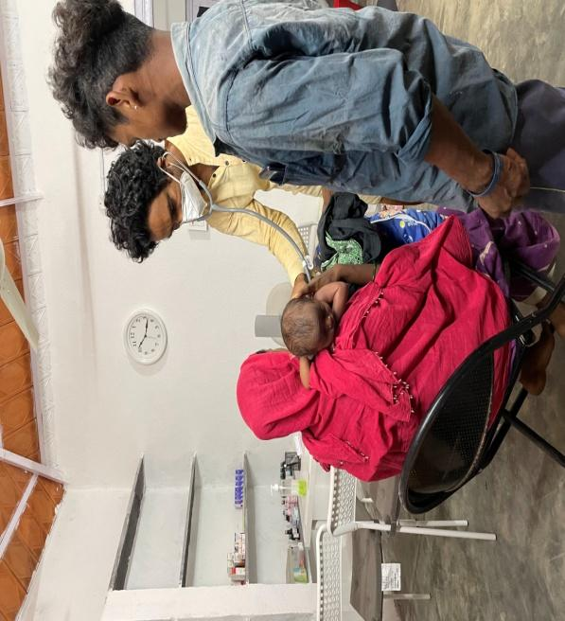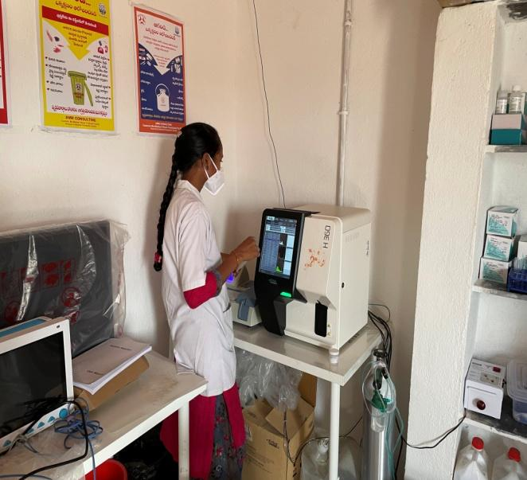

**COMMUNITY HEALTH WORKERS MONTHLY TRAINING:**

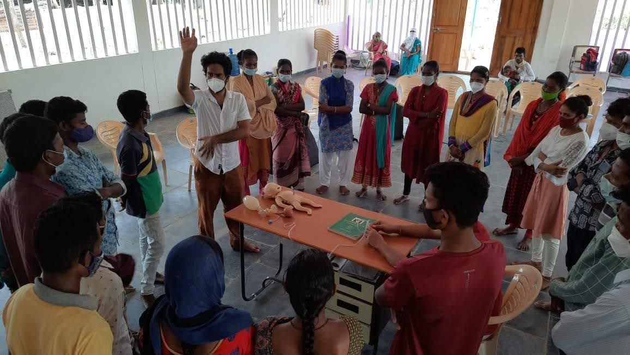

To address the challenges in interior habitations, we have identified one community member from each habitation. These individuals have been motivated & regularly trained by our team to provide much needed healthcare services at the door-step (Home Based) to their community members. These individuals are called “Community Health Workers” (CHW).

Each CHW has been provided with medical kit to provide the health services within the habitation & early identification of high-risk cases which need referral to institutions. The whole idea of this CHW program is to empower the local youth to take charge of their health & also of their community.

Now our trained CHWs can identify high-risk newborns & high-risk pregnancies. They can also do malaria tests and within minutes identify the type of malaria, provide treatment and also refer high-risk cases to higher centre if needed.

| **INTERVENTIONS DONE BY COMMUNITY HEALTH WORKERS WITHIN HABITATIONS** | |
| --- | --- |
| Community health workers trained | 51 |
| Mandals covered | 13 |
| Habitations covered | 54 |
| Population covered | 10000+ |
| No. of Pregnant women - Antenatal checkups | 232 |
| High -risk pregnancies identified & referred | 57 |
| No. of safe deliveries conducted at habitation | 45 |
| Home based newborn care | 307 |
| Total malaria screening done | 889 |
| Total malaria cases identified & treated | 586 |
| Tuberculosis Cases identified & done followups | 17 |
| Patients referred to higher centres | 154 |

## STORY OF TRANSFORMATION FROM A POOR HEALTH SEEKER TO A COMMUNITY HEALTH WORKER:

During one of our medical camps, we came across Madavi Sammakka, a 22 year old female, from interior tribal habitation SIRTHANPADU which has very poor connectivity and is 5 kms from nearest connectivity point.

She had severe anaemia where we had found with our medical kit that her haemoglobin was only 1 GRAM/DL & she was resisting the admission to hospital as the majority of community members are usually afraid to visit hospitals due to various traditional beliefs/taboos and like several others in the community, her family also believed in black magic. Few people told us that black magic was doing no good to her, several weeks had passed but she was not recovering & was unable to carry out her daily activities. It was affecting her livelihood also.

After counselling them for almost 1 hour, she was taken to Bhadrachalam Govt Hospital for blood transfusion. Meanwhile when we were getting the blood donors ready, she fled from the hospital back to her habitation. We had to go back to the habitation & counsel her that it may be fatal if transfusion was not done in-time. Finally 2 units of blood transfusion were done & supplements were provided to ensure she recovers well. Now she has 11.9 GRAMS/DL haemoglobin. Moreover she understood that timely intervention has brought a huge change in her health. She came forward to serve her community & is now “community health worker” providing healthcare services to the needy in her habitation.

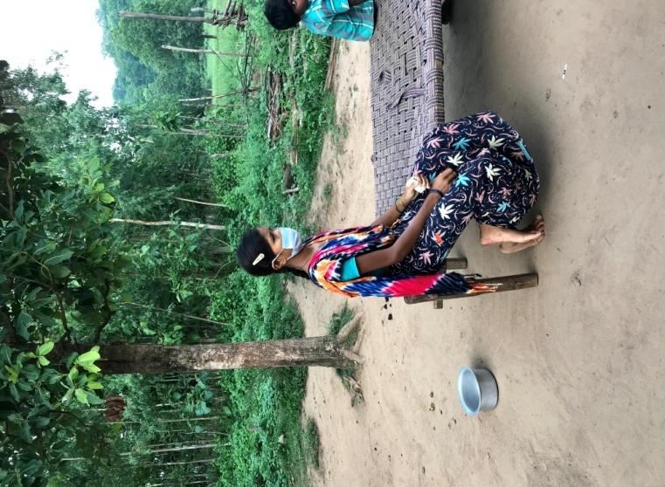 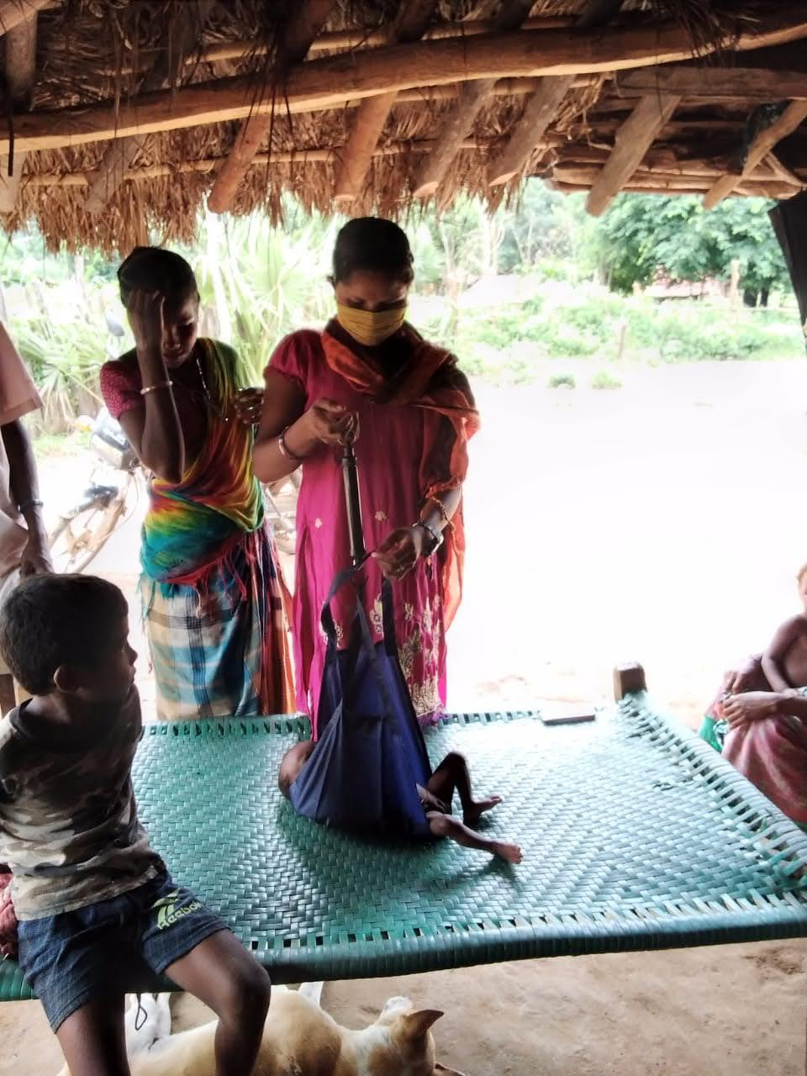

**SEEMANTHAM (BABY SHOWER EVENT):**

To effectively screen all the pregnant women across the tribal habitations, a baby shower event is conducted every month in our health centre premises at Gattumalla village. A group of 25-30 pregnant women from various habitations are invited to our centre on 7th of every month for this event. As a ritual, all the participating pregnant women are provided with new sarees, bangles & fruits. A complete Antenatal Check-up (ANC) is done for each pregnant woman.

Our team conducts health education session for these pregnant women explaining the importance of taking supplements, mentioning Do’s and Don’ts as wells as motivating them to go for institutional deliveries against the more common tradition of home deliveries.

Traditional tribal songs in their local language & dance are performed by our community health workers at the end of event making the pregnant women experience the moments of joy.

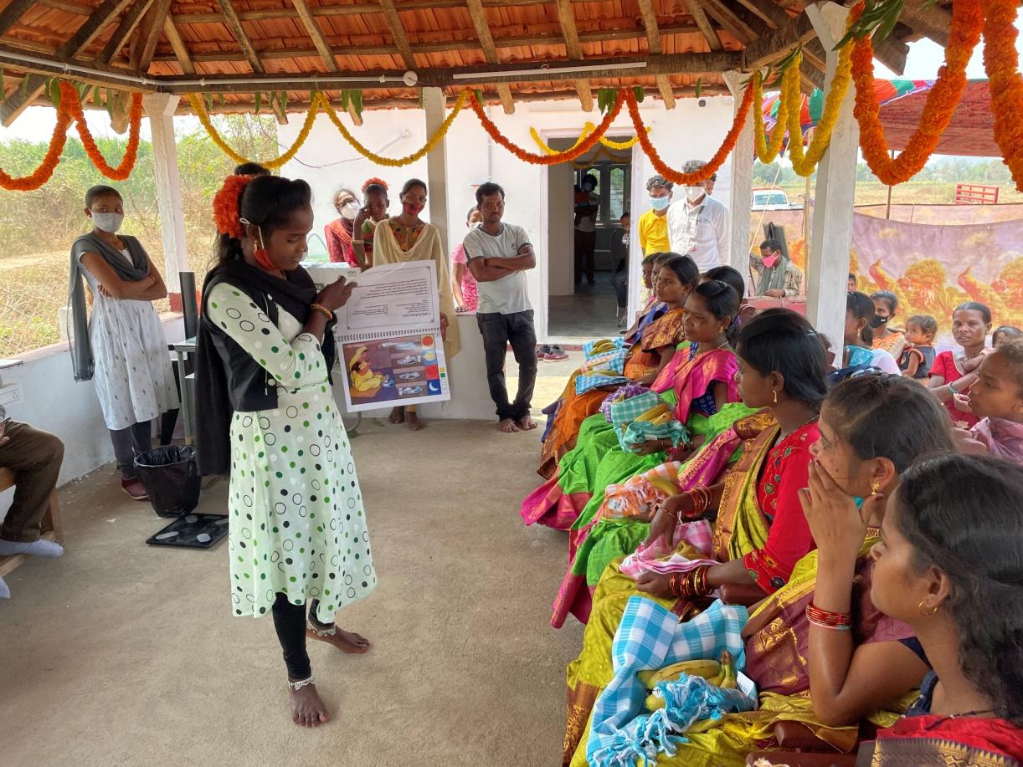

**NUTRITION PROGRAM & NUTRITIONAL ASSESSMENTS:**

Malnutrition & Anaemia prevalence in Under-5 age children and pregnant women is highest in tribal population.

According to our study, 70.2% children are underweight & 62.4% of them have wasting. 99% pregnant women and 98% under-5 age children have anaemia.

I-DO has started providing them our own formulated nutrition powder which has to be consumed every day. To ensure this, spot feeding program has been planned in all the 51 habitations covering over 1800 beneficiaries.

In Under-5 age children, nutritional assessments are done by our team once in 6 months. We were glad to note 39.54% improvement in anaemia cases due to spot feeding program

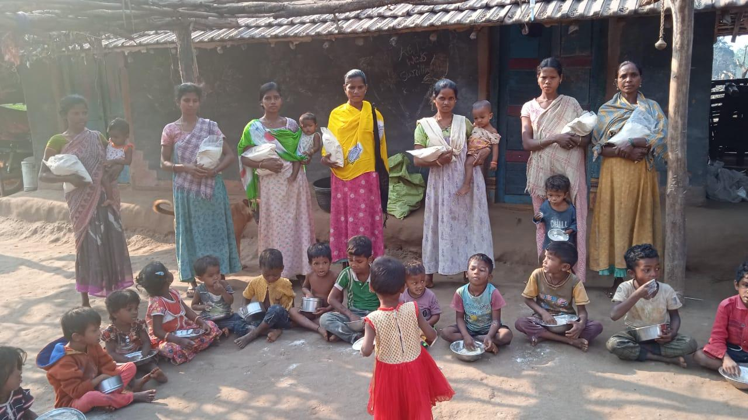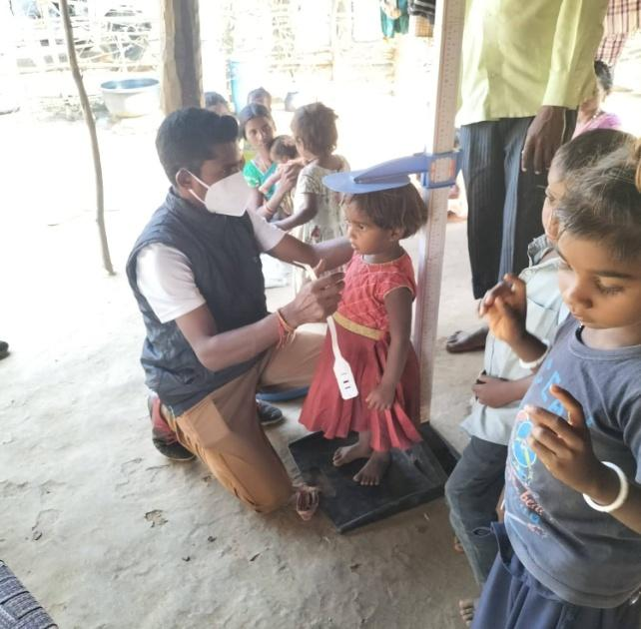

.

**BRIDGE SCHOOLS:**

In the interior habitations there are no anganwadi centres or schools which made education inaccessible to the tribal habitation children. Sending children directly to mainstream schools also was challenging.

To fill this gap we have established 13 BRIDGE SCHOOLS in 13 habitations itself, where they get basic education & mid-day meal. After identifying potential students we motivate them to join into mainstream schools.

| No. of children in our bridge schools | 400+ |
| --- | --- |
| No. of children joined to residential mainstream schools | 74 |

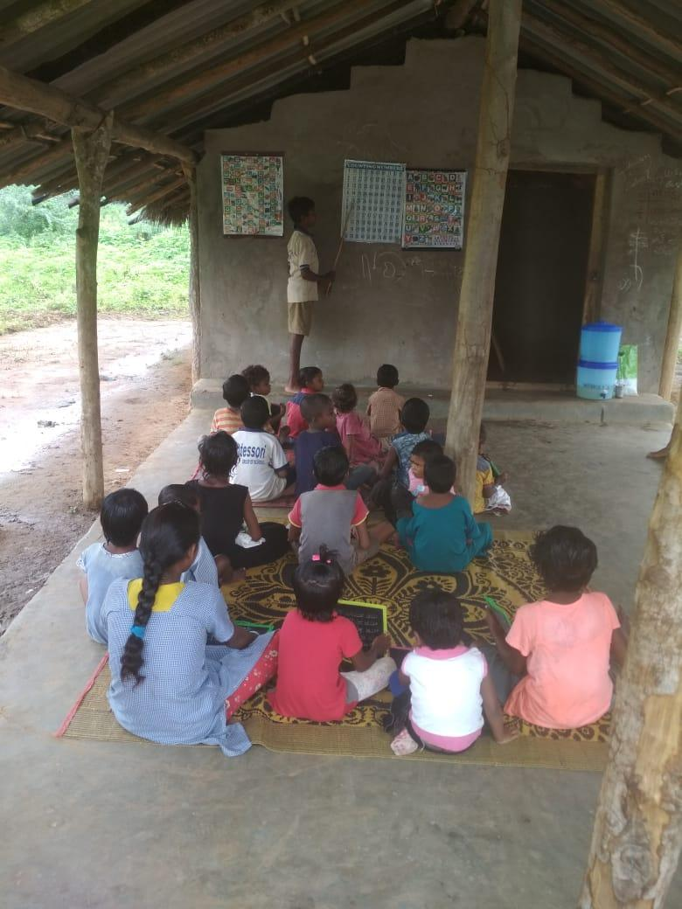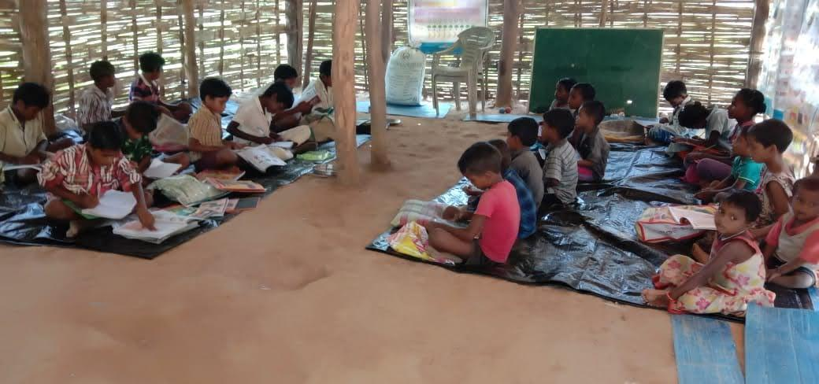



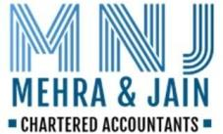

| **Indigenous Development Organization** | | | | | |
| --- | --- | --- | --- | --- | --- |
| **Income & Expenditure Statement for the period 01/04/2021 to 31/03/2022** | | | | | |
| **Income** | **Amount (Rs.)** | **Amount (Rs.)** | **Expenditure** | **Amount (Rs.) for** | **Amount (Rs.) for** |
| **For FY21-22** | **For FY20-21** | **FY21-22** | **FY20-21** |
| Donations Received | 43,08,646 | 66,07,151 | Ambulance expenses | 21,000 | 1,25,000 |
| Cash Backs | 0 | 0 | Bank Charges | 1,500 | 515 |
| Interest on Fixed deposits | 22,374 | 0 | Communication Expenses | 0 | 0 |
|  |  |  | Electricity Expenses | 42,832 | 10,585 |
|  |  |  | Food Expenses | 0 | 4,170 |
|  |  |  | Fuel Expenses | 3,31,008 | 1,20,258 |
|  |  |  | Plantation expenses | 15,530 | 0 |
|  |  |  | General Expenses | 0 | 4,18,905 |
|  |  |  | Insurance | 22,349 | 2,281 |
|  |  |  | Medical Expenses | 3,02,752 | 88,995 |
|  |  |  | Office Expenses | 84,622 | 2,35,000 |
|  |  |  | Rates &Taxes | 0 | 0 |
|  |  |  | Rent | 2,61,160 | 32,000 |
|  |  |  | Repairs &Maintenance | 1,27,668 | 78,991 |
|  |  |  | Salaries | 9,35,143 | 3,00,051 |
|  |  |  | Toys- School | 0 | 0 |
|  |  |  | Training Expenses | 0 | 0 |
|  |  |  | Transportation Charges | 1,44,448 | 50,947 |
|  |  |  | Travel Expenses | 0 | 0 |
|  |  |  | Vehicle Expenses | 0 | 0 |
|  |  |  | Audit Fee | 0 | 0 |
|  |  |  | Depreciation | 3,89,070 | 1,27,874 |
|  |  |  | Income Tax | 0 | 0 |
|  |  |  | Training to Volunteers | 0 | 1,53,447 |
|  |  |  | Telephone Charges | 0 | 5,484 |
|  |  |  | Incentives to local Volunteers | 7,73,024 | 2,35,788 |
|  |  |  | School Construction | 0 | 47,640 |
|  |  |  | GAS Charges | 0 | 5,770 |
|  |  |  | Festival Expenses | 0 | 10,000 |
|  |  |  | Printing & Stationery | 27,060 | 29,699 |
|  |  |  | Postage Charges | 0 | 280 |
|  |  |  | Accommodation Charges | 10,593 | 13,500 |
|  |  |  | Travelling Expenses | 0 | 35,778 |
|  |  |  | Groceries Distributed | 0 | 1,57,058 |
|  |  |  | Vehicle Repair & Maintenance charges | 0 | 17,820 |
|  |  |  | Solar Lights Distributed | 0 | 1,99,800 |
|  |  |  | Website Charges | 0 | 5,000 |
|  |  |  | Labor charges | 22,900 |  |
|  |  |  | Project expenses | 8,46,772 |  |
|  |  |  | Honorarium | 4,00,000 |  |
|  |  |  | Groceries | 3,20,214 |  |
|  |  |  | Nutrition powder | 1,15,335 |  |
|  |  |  | Chef charges | 32,700 |  |
|  |  |  |  |  |  |
|  |  |  | Excess of Income over Expenditure | -8,96,659 | 40,94,515 |
|  |  |  |  |  |  |
| Total | 43,31,020 | 66,07,151 | Total | 43,31,020 | 66,07,151 |

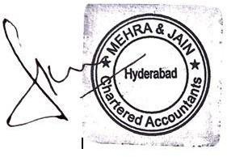



| **Indigenous Development Organization** | | | | | |
| --- | --- | --- | --- | --- | --- |
| **Balance Sheet as on 31/03/2022** | | | | | |
| **Liabilities** | **Amount (Rs.)** | **Amount (Rs.)** | **Assets** | **Amount (Rs.)** | **Amount(Rs.)** |
| **as on 31/03/2022** | **as on 31/03/2021** | **as on 31/03/2022** | **as on 31/03/2021** |
|  |  |  |  |  |  |
| Corpus Donation | 0 | 0 | Fixed Assets | 26,67,098 | 2,95,304 |
| Reserves& Surplus | 35,81,836 | 44,78,495 | Advance Salary |  |  |
| Audit fee Payable |  |  | Cash in Hand | 18,010 | 18,010 |
| Income tax payable |  |  | Bank Balance | 8,96,728 | 41,65,180 |
|  |  |  |  |  |  |
| Total | 35,81,836 | 44,78,495 | Total | 35,81,836 | 44,78,495 |
|  |  |  |  |  |  |





# MEHRA & JAIN CHARTERED ACCOUNTANTS

2ndFloor, Plot No.36, UBI Colony, Road No.3, Banjara Hills, Hyderabad-500036



